Could you outline the steps you would take to install and configure Prometheus using Helm charts on their existing Kubernetes cluster?

What are the commands needed to pull the latest Grafana image from Docker Hub and to start a Grafana server?

Once Grafana is up and running, how would you configure it to use Prometheus as its data source?

1. helm command used to deploy Prometheus

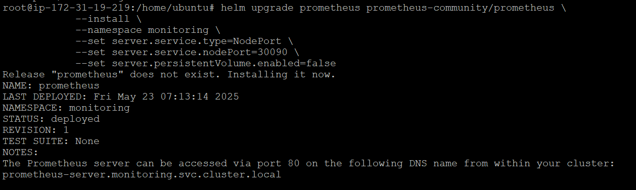

1. helm command used to deploy Grafana

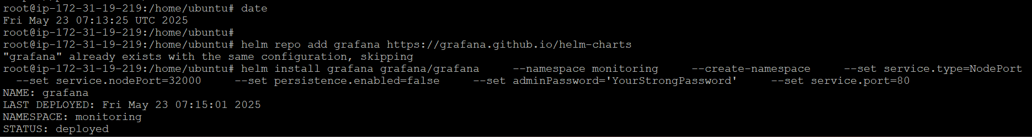

1. screenshot of premetheus

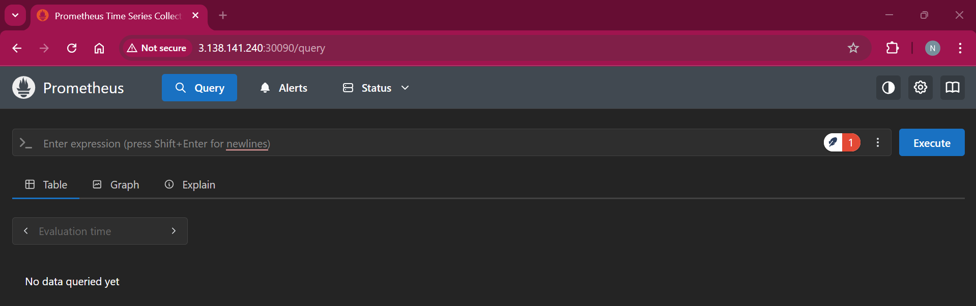

1. screenshot f Grafana

